

TRIBHUVAN UNIVERSITY

Faculty of Computer Science and Information Technology

NET Centric Computing REPORT ON PERSONAL BUDGET TRACKER

Submitted By:
Name: - Anshu Hada
Roll No: 03
Year/Semester: 6th Sem/3rd Year
Submitted To:
Yuva Raj Devkota
National College of Computer Studies Paknajol Marg, Kathmandu

………………………..
Signature

Acknowledgement
I would like to express my sincere gratitude to my teacher for their guidance during the preparation of this project report. Their feedback helped me in understanding the requirements, structure, and documentation standards needed for an organized academic project report.
I am also thankful to everyone who supported the development and testing of this Personal Budget Tracker. The project helped me apply concepts of object oriented programming, layered application architecture, database design, ORM-based data access, and software engineering practices in a practical WPF and C# based desktop development environment.

Abstract

Personal Budget Tracker is a desktop personal-finance application developed in C# using Windows Presentation Foundation (WPF) on .NET, with Microsoft SQL Server as the backing data store accessed through Entity Framework Core. The application allows a registered user to record income and expenses, set overall and per-category monthly budgets, track progress toward savings goals, and review spending through a dashboard and analytical reports built with the LiveCharts charting library. Every read and write operation is routed through a single EF Core DbContext (BudgetTrackerContext) and a set of thin repository classes, so no hand-written SQL is required and the database schema is generated directly from the object model. This documentation presents the analysis, design, and implementation of the system. It describes the problem statement, objectives, feasibility, system design, module-wise implementation, and result analysis of the project. The report includes the Use Case Diagram as the required visual model for understanding user interaction with the system.
.

Contents

1. Introduction 1
1.1. Purpose 1
1.2. Project Scope 1
1.3. Document Convention 1
1.4. Tools and Technologies Used 2
2. Problem Statement 3
3. Objectives 4
4. Feasibility Study 5
4.1. Technical Feasibility 5
4.2. Schedule Feasibility 5
4.3. Operational Feasibility 6
5. System Analysis and Design 7
5.1. System Overview 7
5.2. Major Modules 7
5.3. User Class 7
5.4. Operating Environment 8
5.5. Use Case Diagram 8
5.6. Real Project Screenshots 9
5.6.1. Main Menu 9
5.6.2. Dashboard 9
5.6.3. Budget View 10
5.2.4. Reports and Analytics 10
6. Implementation 11
6.1. Authentication Module 11
6.2 . Data Access Module 11
7. Result Analysis 12
8. Non-Functional Requirements 13
9. Conclusion 13
10. Recommendations 13
11. Future Scope 13

Introduction

Personal Budget Tracker is a complete, story-free but requirement-driven desktop application developed as an academic project using the Windows Presentation Foundation (WPF) UI framework, the C# programming language, and Microsoft SQL Server as the relational database, accessed entirely through Entity Framework Core (EF Core). The application lets a registered user log in securely, record income and expense transactions, define monthly budgets (overall or per category), set and track savings goals, and review their financial activity through a dashboard and a dedicated reports screen.

Purpose

The purpose of this project is to design and develop a complete, layered desktop application that demonstrates practical application of object-oriented programming, ORM-based data access, secure authentication, and software engineering principles within a realistic scope for a semester-length Bachelor's project.

Project Scope

The scope of the project includes user registration and login with per-user data isolation, income and expense tracking with categorization, an overall and per-category monthly budgeting system with 80%/100% usage alerts, savings goal tracking with progress indicators, a dashboard summarizing the current month, a transaction history screen with filtering and search, a reports screen with category breakdown and 12-month trend charts, and a profile screen supporting profile edits, password changes, and light/dark theme switching.

Document Convention

This document follows a standard academic project report format. The main text uses numbered headings and sub-headings, with sample code shown in a shaded monospace block and figures captioned below each image.

Tools and Technologies Used

- Application Framework: Windows Presentation Foundation (WPF), .NET 10 (net10.0-windows)
- Programming Language: C#
- IDE: Visual Studio 2022 (17.10+, .NET desktop development workload)
- Data Access / ORM: Entity Framework Core 10 (Microsoft.EntityFrameworkCore.SqlServer, Microsoft.EntityFrameworkCore.Design)
- Database: Microsoft SQL Server (SQL Server Express / LocalDB supported)
- Charting: LiveChartsCore.SkiaSharpView.WPF for the pie, bar, and line charts
- Security: PBKDF2 password hashing (Rfc2898DeriveBytes, SHA-256, 100,000 iterations, per-user random salt)
- UI Text/Styling: WPF Styles and Resource Dictionaries (LightTheme.xaml, DarkTheme.xaml, Styles.xaml)
- Version Control / Backup: local project folders maintained across development phases

Problem Statement

Individuals frequently struggle to track where their money goes each month because income and expenses are scattered across bank statements, cash transactions, and mental notes rather than a single, organized system. Building a complete personal-finance tracker requires the integration of multiple components such as secure user authentication, transaction recording, category-based budgeting with real-time alerts, savings-goal tracking, and visual reporting - all while keeping each user's financial data isolated and private. Managing these components effectively while maintaining a consistent, responsive desktop experience can be challenging for beginner and student developers.
Therefore, this project aims to develop a Personal Budget Tracker using WPF, C#, and EF Core over SQL Server that provides a secure, interactive, and informative way for a single user to manage their personal finances. The application allows a user to register an account, log income and expenses under clear categories, set monthly budgets that warn them before they overspend, save toward named goals, and review their financial trends through charts and a filterable transaction history.

Objectives

The objectives of this project are:
- To design and develop a complete, secure, multi-screen desktop budgeting application using WPF and C#, with per-user data isolation enforced at the data-access layer.
- To implement data access using an ORM (Entity Framework Core) rather than hand-written ADO.NET code, generating the database schema directly from a Fluent-API-configured model.
- To implement reusable, object-oriented components - including a centralized authentication service, a password hashing service, a session manager, and one repository class per entity - rather than duplicating data-access logic across views.
- To build a complete and polished user-facing flow, from login and registration through the dashboard, budgeting, savings goals, transaction history, reports, and profile settings, using a consistent, theme-aware visual style.

Feasibility Study

Technical Feasibility

The project uses WPF and .NET, a framework and language taught within the CSIT curriculum, together with Entity Framework Core, a widely documented and freely available ORM, and Microsoft SQL Server / LocalDB, which is free for development use. All required systems - data binding, navigation, the DbContext change tracker, and automatic SQL generation - are built into the .NET and EF Core ecosystem, and the LiveCharts library used for charting is open source. No paid software, external server infrastructure, or specialized hardware was required, which made the project technically feasible to complete on a personal computer.

Schedule Feasibility

The project was broken down into small, sequential development phases so that each layer (models, database context, repositories, authentication, individual feature views, and visual polish) was built, tested, and confirmed working before moving to the next. This phase-based approach kept the workload manageable within a single semester. The major development phases are summarised below.

Phase | Focus Area
1 | Requirements gathering, entity design, and database schema planning
2 | WPF project setup, theming (Light/Dark), and navigation shell
3 | EF Core DbContext, Fluent API model configuration, and DatabaseHelper
4 | Authentication: registration, login, PBKDF2 hashing, and session management
5 | Income and Expense modules with repository-based CRUD operations
6 | Budget module with usage percentage, colour-coded status, and alerts
7 | Savings Goals module and Dashboard summary cards
8 | Transaction History filtering/search and Reports & Analytics charts
9 | Profile/Settings screen, theme switching, and visual polish
10 | Testing, bug fixing, build creation, and documentation

Operational Feasibility

The finished application runs as a standalone Windows desktop program connecting to a local or LAN SQL Server instance. It does not depend on any external web service or third-party account, and the database schema is created automatically on first run via context.Database.EnsureCreated(), so it can be deployed and demonstrated on a typical classroom computer without manual database scripting.

System Analysis and Design

System Overview

The application is a single-user-per-session, offline-capable desktop system connected to a shared SQL Server database. The user interacts with the system entirely through mouse and keyboard input inside a WPF shell window with sidebar navigation. After logging in, the user is taken to a Dashboard summarising the current month, and can navigate between Income, Expense, Budget, Savings Goals, Transaction History, Reports, and Profile screens. A SessionManager holds the logged-in user for the application's lifetime, and every repository query filters by UserId so that one user can never see another user's records.

Major Modules

- Authentication Module - registration, login, PBKDF2 password hashing, and session management
- Data Access Module - the EF Core DbContext (BudgetTrackerContext) and one repository class per entity
- Income / Expense Module - add, edit, delete, and list transactions with category and payment method
- Budget Module - overall and per-category monthly budgets with percent-used status and alerts
- Savings Goals Module - target/saved amount tracking with progress indicators
- Dashboard Module - current-month summary cards, expense-by-category pie chart, income-vs-expense bar chart
- Transaction History Module - combined, filterable view of Income and Expenses
- Reports & Analytics Module - monthly breakdown and 12-month spending trend
- Profile / Theme Module - profile edits, password change, and Light/Dark theme switching

User Class

There is a single user class for this system: the registered User. Each user has their own account (email and hashed password), and is expected to have basic familiarity with a typical desktop form-based application (text fields, buttons, and data grids).

Operating Environment

The application runs as a standalone Windows desktop executable built with WPF on .NET. It requires a reachable Microsoft SQL Server instance (a local default instance, SQL Server Express, or LocalDB), configured through the connection string in Config/AppConfig.cs. No internet connection is required once the database server is reachable on the local machine or network.

Use Case Diagram

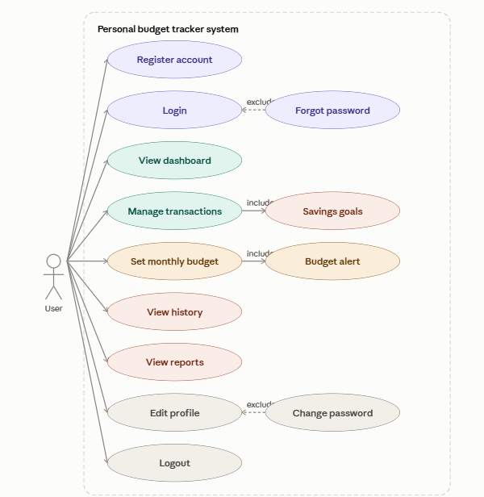

Fig 1: Use Case Diagram for Personal Budget Tracker

Real Project Screenshots

Main Menu
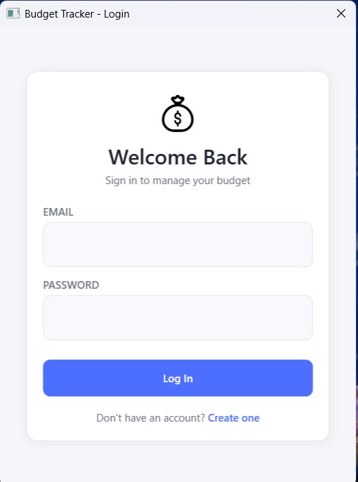

Fig 2: Main menu of Personal Budget Tracker

Dashboard
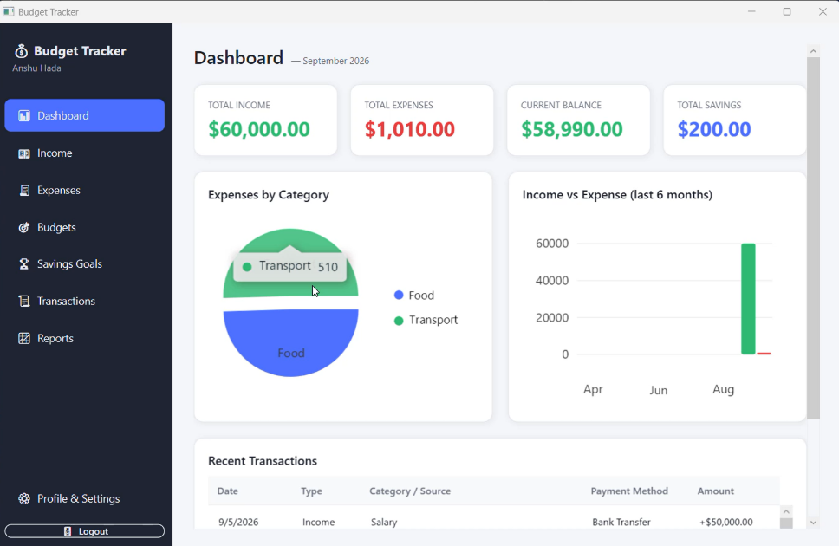

Fig 3: Dashboard

Budget View
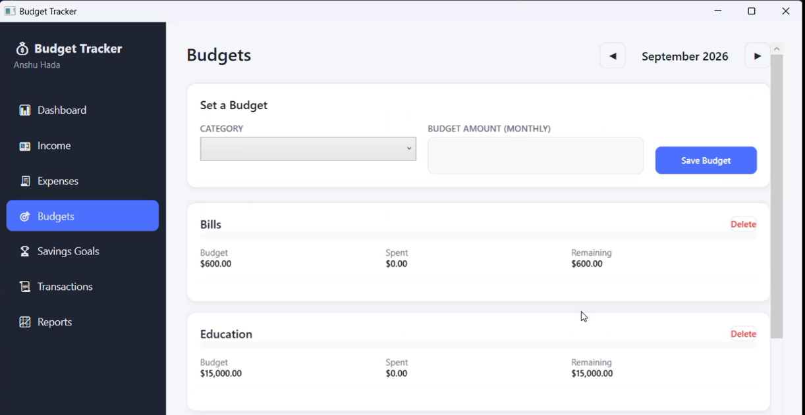

Fig 4: Budget screen showing overall and category budgets

Reports and Analytics

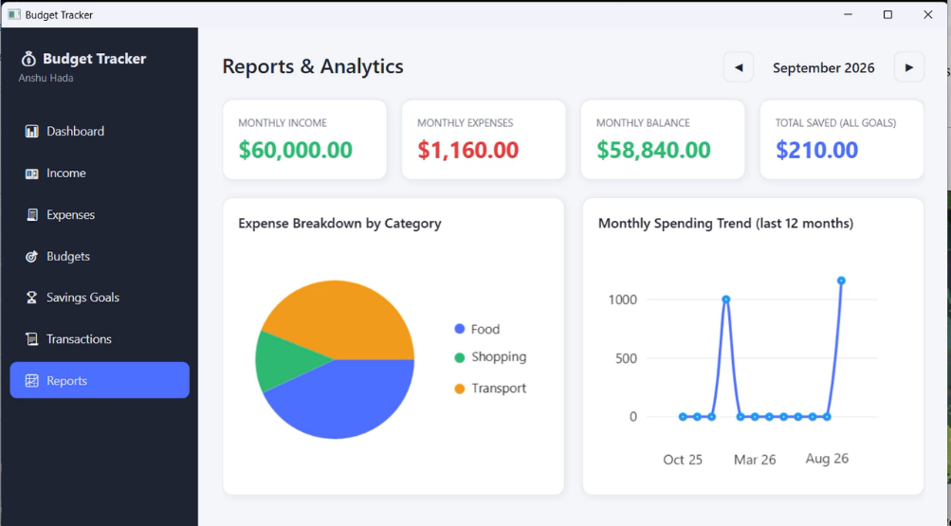

Fig 5: Reports screen showing category breakdown and spending tren

Implementation

This section describes each major module of the application along with a representative code sample and a short description of how it works. Screenshots for each module are to be inserted at the marked locations.

Authentication Module

The AuthService class validates registration and login input, and works together with PasswordHasher, which hashes and verifies passwords using PBKDF2 (Rfc2898DeriveBytes) with a 128-bit random salt per user, a 256-bit derived key, and 100,000 iterations of SHA-256, so no plaintext password is ever stored or compared directly.

public static (string Hash, string Salt) HashPassword(string password)
{
byte[] saltBytes = RandomNumberGenerator.GetBytes(SaltSize);
byte[] hashBytes = Rfc2898DeriveBytes.Pbkdf2(
password: password, salt: saltBytes,
iterations: Iterations, hashAlgorithm: HashAlgorithmName.SHA256,
outputLength: HashSize);
return (Convert.ToBase64String(hashBytes), Convert.ToBase64String(saltBytes));
}

. Data Access Module

A single BudgetTrackerContext defines one DbSet per entity and configures the entire schema through the Fluent API in OnModelCreating - table names, keys, required fields, maximum lengths, decimal precision, foreign keys with cascade delete, check constraints, and filtered unique indexes - instead of scattering data-annotation attributes across the model classes.

modelBuilder.Entity<Expense>(e =>
{
e.ToTable("Expenses", "dbo");
e.HasKey(x => x.ExpenseId);
e.Property(x => x.Amount).HasColumnType("decimal(12,2)");
e.HasIndex(x => new { x.UserId, x.ExpenseDate });
e.HasOne<User>().WithMany().HasForeignKey(x => x.UserId)
.OnDelete(DeleteBehavior.Cascade);
e.ToTable(t => t.HasCheckConstraint("CK_Expenses_Amount", "Amount > 0"));
});

Result Analysis

The completed application was tested by registering multiple accounts, recording income and expenses across several categories, setting overall and per-category budgets, and reviewing the resulting dashboard and reports. The table below summarises the outcome of testing for each major module.
Module | Expected Result | Status
Authentication | Register and login succeed with valid input; invalid input and wrong passwords are rejected with a friendly message | Working
Data Access (EF Core) | Database and schema are created automatically on first run; all CRUD operations persist correctly | Working
Income / Expense | Records can be added, edited, deleted, and are correctly scoped to the logged-in user | Working
Budget & Alerts | Progress bar colour and warning/error alert trigger correctly at 80% and 100% usage | Working
Savings Goals | Goals track saved vs. target amount and mark themselves complete correctly | Working
Reports & Charts | Pie and trend charts reflect the correct totals for the selected month/period | Working
Theme Switching | Light/Dark theme applies instantly and is remembered per user on next login | Working

During development, a small number of issues were identified and resolved through testing - for example, the initial per-category budget uniqueness check allowed duplicate rows before the filtered unique index was added, which was fixed in OnModelCreating, and a rounding mismatch between PercentUsed and the progress bar fill, which was resolved by introducing the capped ClampedPercent property. These issues and fixes reflect the iterative testing approach used throughout the project.

Non-Functional Requirements

- Performance: EF Core queries are scoped and filtered by UserId and indexed columns, keeping typical screen loads fast even as transaction history grows.
- Security: passwords are never stored in plaintext; PBKDF2 with a per-user salt and 100,000 iterations is used for hashing and verification.
- Usability: a consistent sidebar navigation shell and shared styling keep every screen predictable and easy to learn without a manual.
- Portability: the application runs as a standalone WPF build; only a reachable SQL Server/LocalDB instance and connection string are required.
- Maintainability: a single DbContext, one repository per entity, and centralised services (AuthService, SessionManager, ThemeManager) keep data-access and cross-cutting logic centralised and easy to extend.
- Data Integrity: foreign keys, check constraints, and filtered unique indexes enforce the business rules (positive amounts, one budget per category per month) at the database level, not only in application code.

Conclusion

This project successfully delivers a complete, working Personal Budget Tracker built with WPF, C#, Entity Framework Core, and SQL Server, covering secure authentication, income/expense tracking, budgeting with real-time alerts, savings goals, a dashboard, transaction history, and analytical reports. The project demonstrates practical use of object-oriented programming and layered architecture - models, a DbContext with Fluent API configuration, repositories, services, and views - alongside ORM-driven schema generation, LINQ-based data access, and WPF data binding and theming.

Recommendations

- Switch from EnsureCreated() to EF Core Migrations once the schema needs to evolve over time without dropping existing data.
- Add a Categories table so users can define and manage their own custom expense categories instead of a fixed list.
- Add pagination to Transaction History once the number of records per user grows very large.

Future Scope

Future versions of this application could include multi-currency support, recurring/scheduled transactions, exportable PDF or Excel reports, budget rollover between months, richer notification options (e.g. email alerts), and a companion mobile or web client sharing the same SQL Server backend through a Web API layer.

